# Report for Jaden Beyer (2024-10-01 to 2024-10-31)

Average Bat Speed: 61.19

Average Rotational Acceleration: 12.33

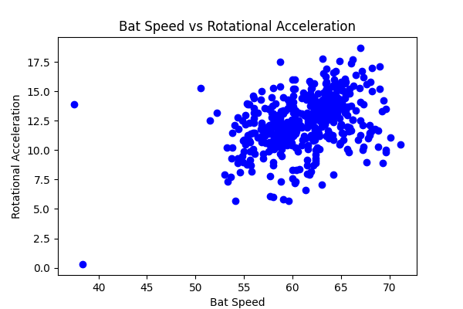

## Comments

Add comments here...